Algorithm question paper

1. What is greedy algorithm.
2. What is dynamic problem approach to solve a computational problem? And how its complexity is reduces, explain with example.
3. What is Heap data structure? Write the algorithm for heap sort using Min heap and analyse its time complexity.
4. What is the worst case of quick sort algorithm?
5. What is heapify? And what is the time complexity of heapify.
6. What are the properties of Red-Black tree.
7. Why do we need to balance the binary search tree
8. What are the symmetric and transitive properties of asymptotic notations?
9. Explain the concept of backtracking.
10. Explain greedy approach. Write general greedy algorithm.
11. Find the shortest path from source vertex A to vertex H using “Dijkstra algorithm”

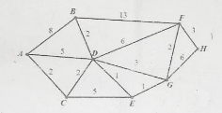

1. Write a algorithm to construct minimum spanning tree (MST) using kruskal’s algorithm and trace the algorithm on the following graph

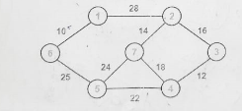

1. Write the recursive and iterative approach to finding the reverse of a number and analyse it’s time complexity
2. Explain KMP algorithm for string matching with example.
3. Explain merge sort and its time complexity with example.